DENTIST MANAGEMENT SYSTEM

# Introduction

This document is intended to understand the technical implementation of Dentist Management System.

## Purpose

The main purpose of our system is to make Clinic task easy and to develop software that replaces the manual Dentist system into automated Dentist management system. Also, patients will be able to book appointments online.

## Scope

The system will store the patient information in database which will be used for future usage. The current system in use is a paper-based system. It is too slow and cannot provide updated lists of patients within a reasonable timeframe. The intention of the system is to increase the number of patients that can be treated accurately.

# Overall Description

System will consist of 4 modules:

* **Super admin:** Will have control over the whole system. He will be able to add, delete and modify the system.
* **Doctor (Admin)**: Doctors are able to see the respective appointments taken. And also can view patient’s details and records. It will include following sub-modules:
  + **Appointments**: This module will list all the appointments for the day.
  + **Patient details**: This tab will display the details of the active patient.
  + **Reschedule**: To reschedule the appointment.
  + **Prescription**: This module will allow the doctor to generate prescription for the patient.
  + **Case Sheet**: If the patient is coming for follow up then doctor can view that patient’s history in this tab.
  + **Questionnaire**: Before treatment, patients will have to answer a questionnaire for the doctor to decide on the medicines to be given. The questionnaire will include questions like whether patient is suffering from any other disease etc.
  + **Consent form**: Patients will be given a consent form before treatment based on the questionnaire answered.
  + **Medical certificate**: Registered patients can apply for medical certificates here.
  + **Family**: This tab will contain details of family members of patients.
  + **Doctors**: E.g. If the patient is required to do any kind of test, his doctor will recommend the specialized doctor. Such references will be listed in this tab.
  + **Pathology**: All the tests patient is required to do will be listed in this tab.
  + **Lab**: _______________________________________
  + **Invoice**: This will list the bill of the patient.
  + **Statistics**:_______________________________________
  + **Search**: This tab will let the doctor search the family members of the patients currently taking treatment in the clinic.

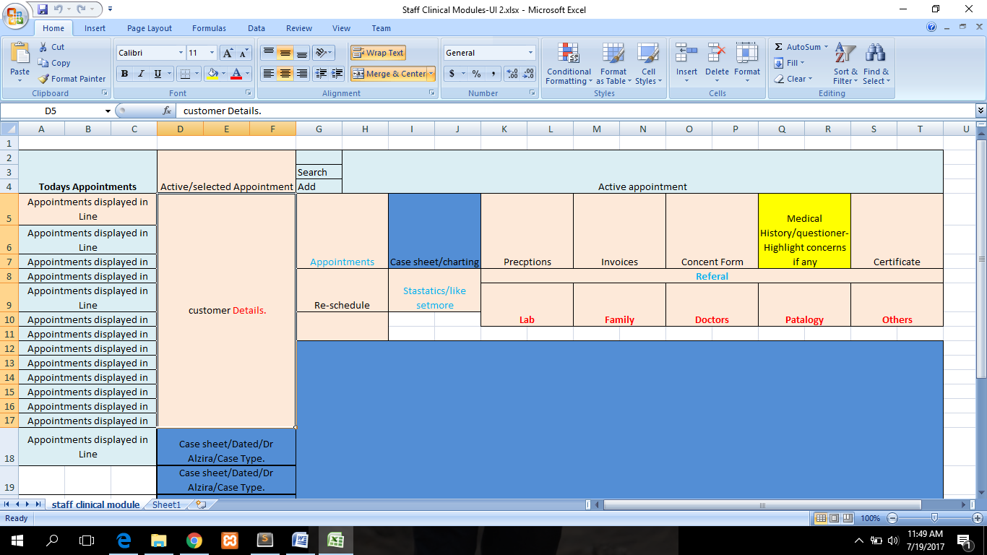

* **Receptionist:** handles tasks like patient’s registration as well as doctor consultation and scheduling time allocation, appointment scheduling.
  + **Appointments:** This section will list all the appointments for the day. It will have 3 more sub sections that is arrived, active and complete appointments. Once the patient arrives in the clinic he will be marked arrived and push notification to the doctor. When arrived patient is sent in for the treatment he will be marked as active. And when the active patient is done, receptionist will mark him as complete.
  + **Selected appointment:** This section will show active patients details.
  + **Customer details:** This section will show details and history of active patient.
  + **Search:** This tab will let the receptionist search the family members of the patients currently taking treatment in the clinic.
  + **Add**: This tab will let the doctor add family members of the patients currently taking treatment in the clinic to his account.
  + **Selected appointment details**: This section will details of the active patient.
  + **Prescription**: This module will allow the receptionist view the prescription.
  + **Invoice**: Receptionist can view or control the invoices.
  + **Consent form**: Patients will be given a consent form before treatment based on the questionnaire answered. It require digital signature.
  + **Questionnaire**: Before treatment patient will have to answer a questionnaire.
  + **Medical certificate**: Registered patients can apply for medical certificates here.
  + **Family**: This tab will contain details of family members of patients.
  + **Doctors**: Eg. If the patient is required to do any kind of test, his doctor will give him a reference of that doctor. Such references will be listed in this tab.
  + **Pathology**: All the tests patient is required to do will be listed in this tab.
  + **Lab**: If patients tooth needs to be replaced, then his tooth details are sent to the lab. Lab then makes a tooth with those details.
  + **Re-schedule**: To reschedule the appointment.
  + **Pre-post medical instructions**:

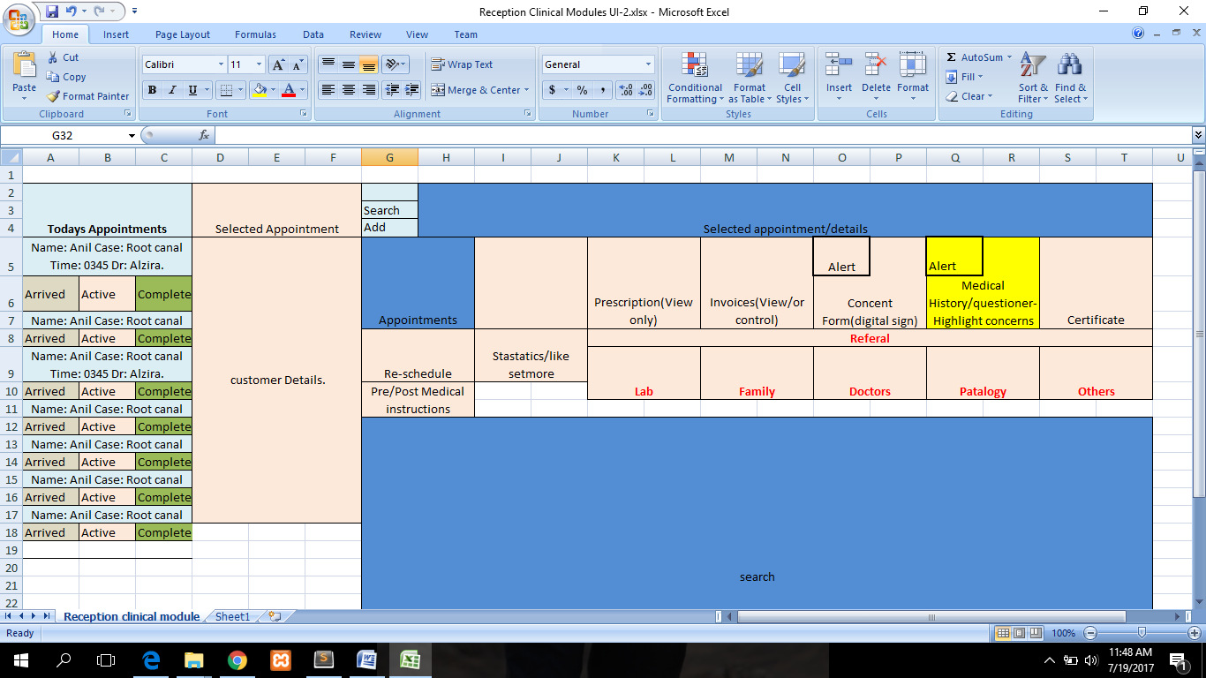

* **Patient:** Anyone can view the information of the clinic. Patients can view their own prescriptions and doctors details and timings. And also can take appointment online.